Time http://time.com/3824917/crickets-sustainable-protein/

HEALTH DIET/NUTRITION

Eating Insects Isn’t as Eco-Friendly As People Say
- Mandy Oaklander @mandyoaklander

April 20, 2015

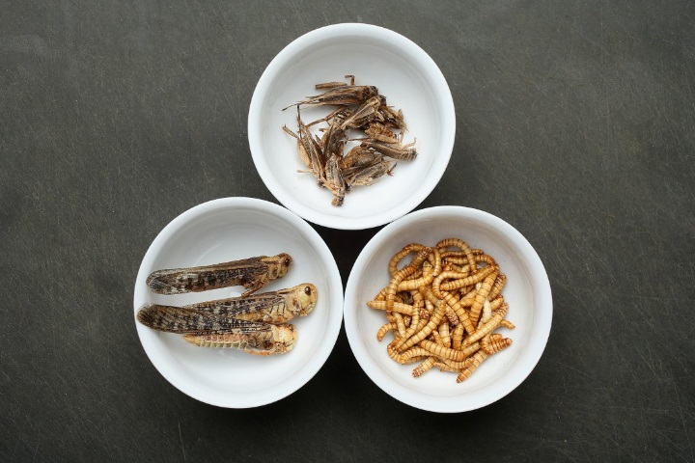
Sean Gallup—Getty ImagesDried grasshoppers, mealworms and crickets seasoned with spices

Crickets aren't so green after all
Recommended by
Crickets are often trumpeted as the future of food, an edible, eco-friendly solution to a some-day protein shortage that livestock just can’t fix. Even the United Nationspromotes insect-eating as a promising, protein-packed way to feed the 9 billion people that will live on earth in 2050. “A benefit of insects as an alternative animal protein source is that they can be reared sustainably on organic side streams (e.g. manure, pig slurry and compost),” their report reads.
Because insects emit far fewer greenhouse gases than livestock and consume way less water, they have a comparatively tiny ecological footprint, and they’re thought to thrive on basically anything, even organic waste. That last point sums up the main ecological appeal of eating insects; growing the grain used in animal feed takes up huge water and energy resources.
But do crickets really have the potential to be the new beef? Not yet, according to a new study published in the journal PLOS ONE. When researchers raised crickets on several different diets and tried to see how much protein they could squeeze out of them, they got some disappointing
results: just not a whole lot of protein.
MORE: Why, On Second Thought, Maybe You Shouldn’t Start Eating Bugs
In the experiment, researchers raised crickets on one of five different diets. They replicated each diet three times and harvested the crickets after two weeks. One group ate corn-, soy- and grain-based feed, while others survived on food waste or crop residue. The researchers measured how big the crickets grew and how much edible protein they produced.
Diet made a huge difference, the study authors found. Those that ate a diet of processed food waste had feed and protein conversion rates no more efficient than that of chickens. Nearly all those fed straight food waste died before they could be harvested. And the most successful crickets were those that ate a grain-based diet similar to what most poultry eat. They had a 35% protein conversion rate, which is only slightly better than chickens.
So even if the whole world took a page out of Mexico’s cookbook and developed an appetite for chapulines—crunchy fried crickets—the small protein payoffs may not even be worth it if we’re feeding them what chickens eat, the authors suggest.
“I think the sustainability claims on this topic have been overstated given the current state of knowledge,” wrote study author Dr. Mark Lundy of the University of California Division of Agriculture and Natural Resources in an e-mail.
Even if they can’t survive on as many organic sidestreams as we originally thought, Lundy doesn’t think that insects are out of the running as the future of food.
“I’m all for exploring alternatives, and I am impressed by the amount of innovation that has sprung up around insect cultivation and cuisine in the last few years,” he says. “However, I also think we need to be clear-eyed about what the sustainability gains are and aren’t, and focus our innovative efforts and limited resources to where they will have the most lasting impact.”
Swapping chickens for crickets–while feeding them the same thing—is unlikely to make a real difference. “Insect cultivation is more likely to contribute to human nutrition at a scale of economic and ecological significance if it does not rely on a diet that competes with conventional livestock,” he says, “but more innovation is needed for this to become a reality.”

PERSONAL FINANCE

Why, On Second Thought, Maybe You Shouldn’t Start Eating Bugs
By Brad Tuttle @bradrtuttleMarch 15, 2011
Follow @TIMEBusiness
Not because, well, because they’re bugs—but because it turns out they’re as expensive as beef or caviar.
The idea has surfaced that insects could be the creepy-crawly miracle food of the future. And while grasshoppers and crickets are indeed good sources of protein and low in fat, they’re not all that cheap to raise and bring to market. Not yet anyway.
The NY Times reports on the efforts in the Netherlands to popularize adding insects to the human diet. At a membership-only warehouse type store called Sligro, customers can head up to the meat counter for beef and pork, as well as locusts, buffalo worms, and Bugs Nuggets, which are made with ground mealworms.
Sligro!? Ground mealworms!? Who is running this place, Professor Snape?
Beyond the marketing and gag-reflex issues, there’s another hurdle for those hoping to make insect eating mainstream in the West. That hurdle, according to folks who raise bugs on Dutch farms, is price:
“Wholesale, insects are similar in price to beef now,” Roland van de Ven said, citing the labor-intensive farming methods used. “Locusts are more like caviar.”
Margot Calis, 62, who works with her daughter Marieke on the farm, which employs 10 people, agreed. “The price of insects is much too high,” she said. “There is lots of manual labor involved, and it is too expensive.”

