BE RESPONSIBLE by…
Prioritizing and do the most important things first
- Vocabulary Assessment Tuesday (11/22)
- Prioritize and work on ARGUMENTATIVE ESSAY!
- November One-pager due next WEDNESDAY (11/30)
Monday, November 21, 2016 Sacred Writing
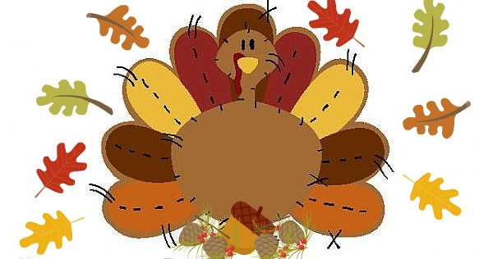
Readers’ Workshop:
- Independent Reading
Writers’ Workshop:
- Review mentor text – Junk Food & Single Parent Struggle
- For/Against
Vocabulary/Grammar Workshop: UNIT 3
- Turn in Vocabulary MENU
- Review Game
- Study for Test tomorrow
Tuesday, November 22, 2016 Sacred Reading
Readers’ Workshop:
- Continue Independent Reading for November One-pager (due next Wed. 11/30)
Writers’ Workshop:
- “Guide Book” and Guided Draft
- Outline DUE MONDAY
Vocabulary/Grammar Workshop:
- Unit 3 Assessment
Wednesday, November 23, 2016 Sacred Writing
No School

Thursday, November 24, 2016 Sacred Reading
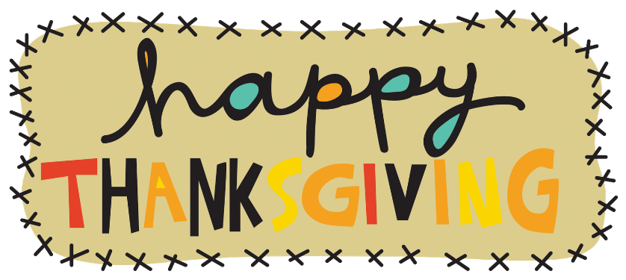
Friday, November 25, 2016 Sacred Choice
Enjoy Shopping

