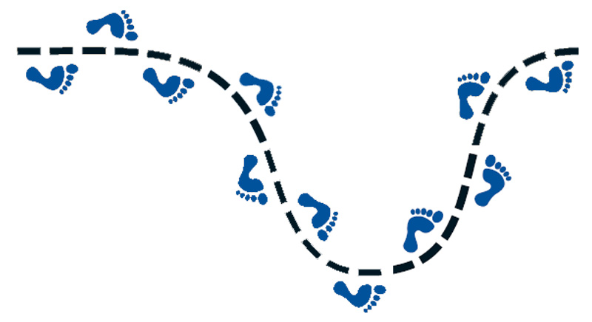
Begin with the End in Mind and Be Proactive
Follow these STEPS
Final Copy Due
________________________
Argumentative Essay
My topic is _____________________________________
My Claim is: __________________________________________________________
Guided Draft | Building Block | Instruction Date | Due Date | I completed work
Outline | 1 | Tues, 11/22 | Mon. 11/28
Introduction (practice 11/29) | 2 | Wed, 11/30 | Thurs. 12/1
Body: Reasons | 3 | Thurs, 12/1 | Wed 12/7 (due with draft final)
Counterclaim | 4 | Fri 12/2 | Wed 12/7
Rebuttal (one more fact) | 5 | Fri 12/2 | Wed 12/7
Conclusion | 6 | Mon 12/5 | Wed 12/7
Draft Due | 7 | Wednesday, 12/7
____________________________________________________________________

Counterclaim: ___________________________________________________________________
_______________________________________________________________________________
Rebuttal: _______________________________________________________________________
_______________________________________________________________________________
Hook: __________________________________________________________________________
Something to think about: _________________________________________________________
_______________________________________________________________________________

