Name ___________________________________ Block _____ / _____ Date _________________
Root Word Posters
- The final poster must contain NO spelling errors; be neat and be accurate.
- The base root's language of origin must be identified (as Latin or Greek or __?); it must be colored the same color every time it appears on the poster.
- The base root's meaning must be identified; it must be colored a different color every time it appears on the poster.
- The poster must feature a "25-cent" vocabulary word that contains the root; this word must stand out near the top of the poster and be defined.
- The poster must feature four other related words and their definitions. (A related word is a completely different word than the original word, just containing a common root; for the example below, you could not identify novices or renovated related words because they are the same word just in different forms.)
- The related words' definitions must contain the base root's definition within their definitions. When you look up words in the dictionary, the definitions will quite often not contain the actual base root's meaning in the definition. You will need to manipulate the definitions to meet the requirements of the poster.
- Some sort of visual (hand-drawn, clip art, computer image, or sticker) must accompany each of the related words.
Manipulating Definitions
- manipulating noun definitions: these definitions must sound like you're giving information about a person place or thing. These definitions often start with the words a, an, or the, which are followed by a different noun. For example: "terrier (noun) -- a breed of dog who burrows into the earth after game."
- manipulating verb definitions: these definitions must start with the word to followed by an action word. For example: "renovate (verb) -- to make something seem new again."
- manipulating adjective definitions: these definitions often start with "describing a person [or place or thing] who/that _______." For example: "novel (adj) -- describing an idea or concept that is new or original."
- manipulating adverb definitions: these definitions often start with "done in a way that shows _______." For example: "nihilistically (adv) -- done in a way that shows someone has belief in nothing religious or moralistic."

Hints and Tips
innovative (adjective): describing someone who has new and original ideas
comes from the Latin root novus, which means new
Related word #1:  novice (noun)  Someone who is new to an activity, like a sport | Related word #2:  renovate (verb)  To make something seem new again | Related word #3:  Nova Scotia (noun)  a Canadian province whose name means new Scotland | Related word #4:  novel (adjective)  describing an idea or concept that isnew and original

- Not all related words will start with the same letter; there are plenty of nov- (new) words that start with an "n," but there are plenty more that make use of a prefix in front of the root. My kids recognize renovate and innovate as words that fit this category.
- Just because a word has nov- in it, that doesn't mean it's a related word. November, for example, comes from the root novem-, meaning "nine." If you use the bracketed information in the dictionary, you can have your students check that fact out.
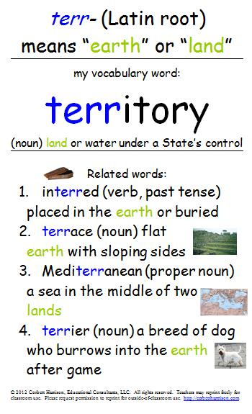

Example:

CCSS RL 7.4, RI 7.4, L7.4, L7.6 Use common, grade-appropriate Greek or Latin affixes and roots as clues to the meaning of a word (e.g., belligerent, bellicose, rebel).
Adapted from http://corbettharrison.com/free_lessons/Root-Posters.htm

