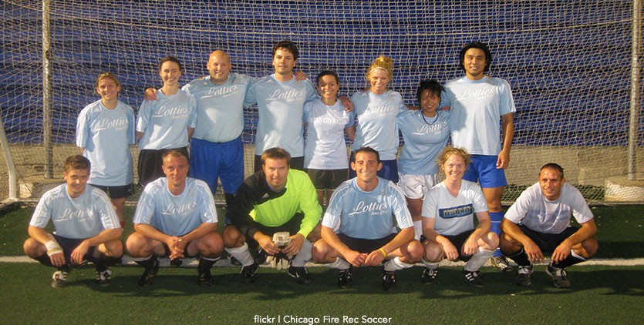
Why Do Kid Need to Play More Co-ed Sports

Whether you're a parent, a coach or just an opinionated person, you most likely have your mind made up already on whether or not you think girls and boys should be able to play sports together. If you're in favor, it may be because you believe the inclusiveness of coed sports benefits both genders, and if you're against, then you may believe it hurts rather than helps one gender over another.
Some of the most common misconceptions that people believe about boys and girls playing together and against one another is that girls will get hurt by the “rough nature” of boys and that boys won't be able to efficiently build their skill levels if they play with girls.
While there may be some validity to those above-mentioned beliefs, they're usually only applicable after puberty. The benefits of both genders playing together before they reach puberty, which is usually around fifth or sixth grade, when they're 11 or 12 years old, far outweighs the cons.
Signing your child up for coed youth sports can help them build important life skills like confidence and can help dispel hurtful gender stereotypes.
The term, “You play like a girl,” has, for the longest time, been used as an insult against boys who aren't up to par with their male peers, while encouraging the false notion that girls are less skilled than their male counterparts.
Most of the time the people saying those slurs have never played on an organized coed team, because if they had, they'd know first-hand that skill levels are not gender-specific and that a more diverse team helps players to be more supportive, encouraging, open-minded, rational, and understanding of one another, even if there are some struggles along the way.
Watch this Always #LikeAGirl video. It provides a great message to children about society's perception of playing "like a girl" and how it needs to change:
During puberty, when a child's body transitions to that of an adult, most sports teams usually won't allow the mixing of the genders due to risks associated with the physical nature of sports. Before that time-frame, boys and girls who play sports together can learn many things about each other and about themselves.
Whether male or female, when one works hard towards a goal or sport, the results speak for themselves. Mind-sets change, and narrow patterns of thinking can be broadened. Image and body issues, a big dilemma for both male and female teens, can be avoided or softened if boys and girls learn early on how to respect one another while their minds are still forming cognitive traits and perceptions.
Co-ed sports help bridge communication gaps between genders as both share a common ground: to play the game while depending on and encouraging one another. If harmony between genders can be resorted for the duration of a soccer, basketball or hockey game, who's to say it won't last off the field or court? Rather than be ignorant or insulting, players of coed teams often support one another in their social circles even after the game has ended.
Parents and coaches would love to see their team win, but they know the importance of their young players' happiness should be priority, not just the scoreboard. The same idea can be applied to coed youth sports: their happiness should be number one and take precedence over the frivolousness of dictating whether or not they should be allowed to play together because they're different.
You may be met with smirks and head-shaking if you suggest forming or having your child join a coed team, but if you take time to understand the benefits you will better be able to explain them to others and hopefully influence their perceptions of how things ought to be.
When children interact with their peers, they often mimic what their parents say. Lead by example of what you want your child to follow – that respect for others both on and off the field, is a right for all people, regardless of gender.
Coed sports will help them learn this first-hand
https://www.youthletic.com/articles/why-kids-need-to-play-more-co-ed-youth-sports/?page=1

